A
Practical Assignment
On
“ Pyhon Programming And Problem Solving Lab ”
Master in Computer Application Ist - Sem


RUNGTA INTERNATIONAL SKILLS UNIVERSITY

SESSION: 2025-26

Submitted To:- Submitted By:-
Miss. Kavita Kanvar Name : aman Sinha
(Assistant Professor) ERP. No. :- RU-25-10156

RUNGATA INTERNATIONAL SKILLS
UNIVERSITY CG

SCHOOL OF INFORMATION TECHNOLOGY
INDEX

S.NO. | NAME OF PRACTICAL | SUBMISSION  DATE | REMARK
1 | Print Following Patterns:-  [A] 1  1 2  1 2 3  1 2 3 4  - 2 3 4 5  [B] *  * * *  * * * * *  * * * * * * *  [C]  *  * * *  * * * * *  * * *  *  [D]  * * *  * *  * *  * * *  [E]  * *  *  * *
2 | Write a program to find the probability of rolling a dice / flipping a coin.
3 | Write a program to find Factorial of a number using Recursion.
4 | Write a program to search for an item in a user – provided list and display the position if found, otherwise print “Item not Found.”
5 | Given a list of employee records as dictionaries, sort them by salary and display the shorted list.
6 | Write a program that reads a text file and counts the number of lines, words, and characters.
7 | Read a sentence and display how many times each word appears, ignoring case and punctuation.
8 | Write a program that lists all files in a directory a categorizes them by file extention.
9 | Inside the circle.py module, create a class Circle that demonstrates by using a separate Point class (for center coordinates). Write the code for both classes.
10 | Add an _init_.py file inside the shapes package that exposes only Circle and Rectangle using _all_. Write code to show how from shapes import * will work after this.
11 | Write a program in main.py to import the shapes package using both:  - Absolute imports  - Relative imports (inside package)
12 | Write a Python program that reads two numbers from the user and performs division. Use try-except to handle the following exceptions:  - ValueError (if the user enters non-numeric input)  - ZeroDvisionError (if the second number is zero)  - Display appropriate error messages.
13 | Create a Python function read_file(filename) that opens and reads a text file. Use try-except-finally to handle:  - FileNotFoundError if the file does not exist  - PermissionError if the file cannot be opened  Finally FileNotFoundError block should print “File read attempt completed.”
14 | Use California Housing datasets to build a Linear Regression model and print MAE and R² score.
15 | Perform Agglomerative Hierarchical Clustering on the Iris dataset.

ASSIGNMENT-01

AIM :- Print Following Patterns:-

[A] 1
1 2
1 2 3
- 2 3 4
1 2 3 4 5
[B]
*
* * *
* * * * *
* * * * * * *
[C]
*
* * *
* * * * *
* * *
*
[D]
* * *
* *
* *
* * *
[E]
* *
*
* *

CODE :-
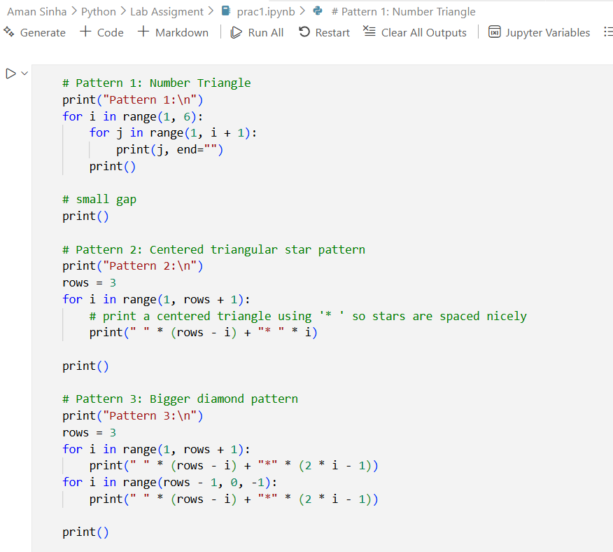
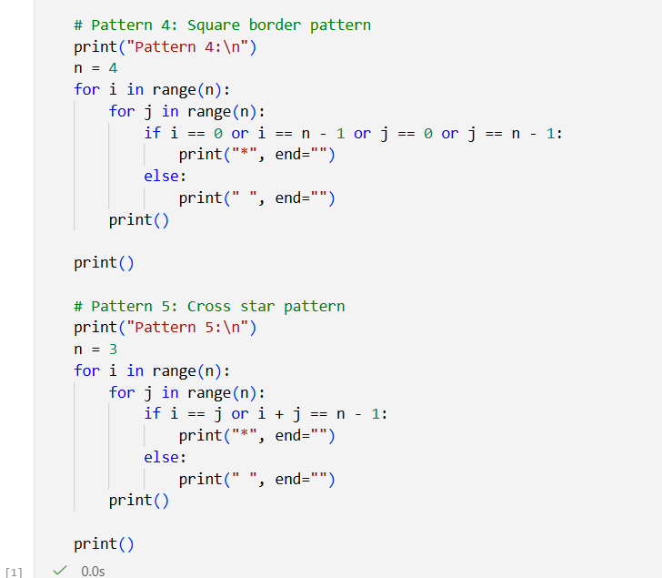

OUTPUT :-

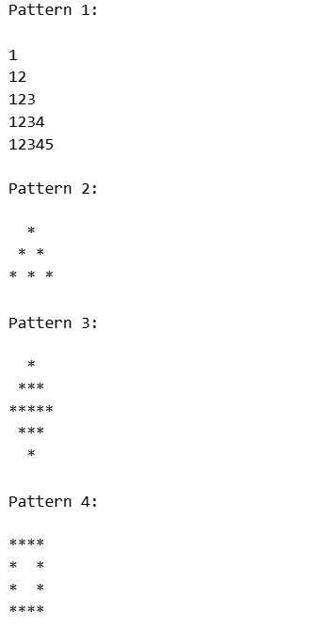
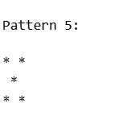

ASSIGNMENT-02

AIM :- Write a program to find the probability of rolling a dice /flipping a coin.

CODE :-
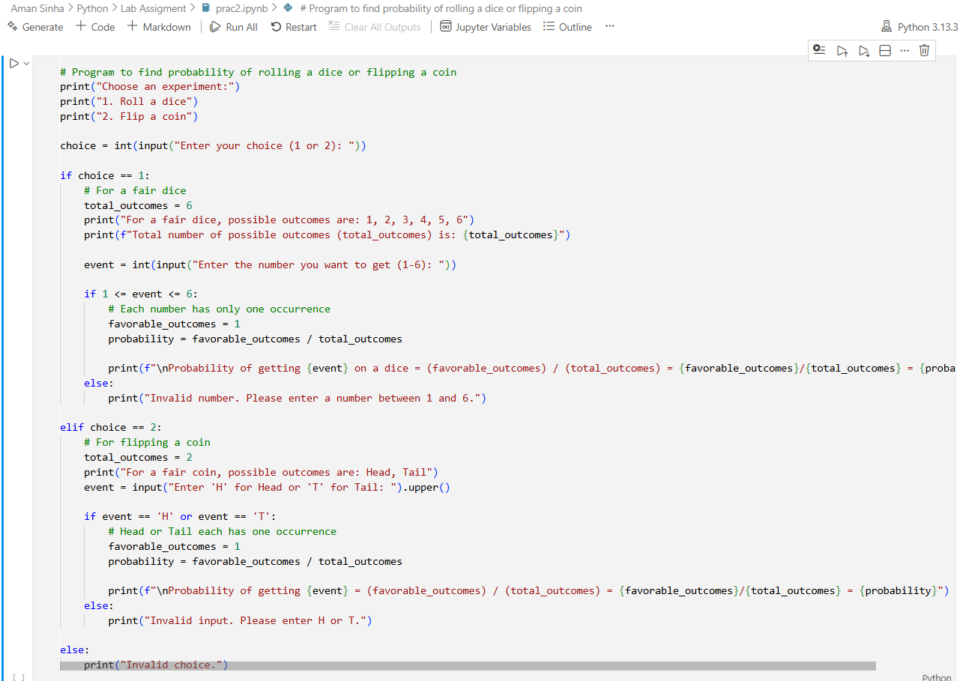

OUTPUT :-

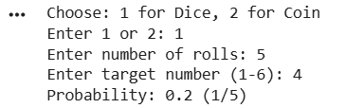
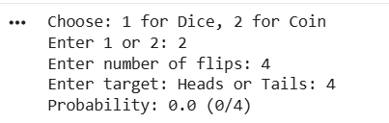

ASSIGNMENT-03

AIM :- Write a program to find Factorial of a number using Recursion.

CODE :-

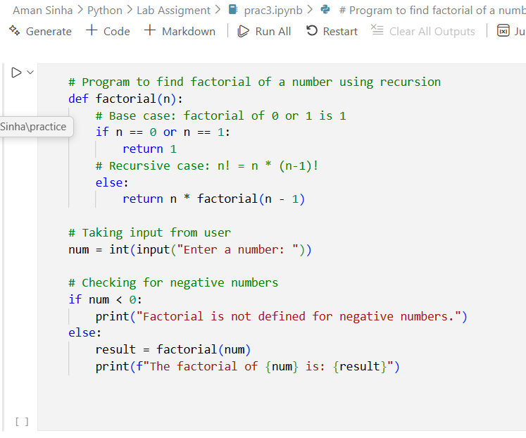

OUTPUT :-

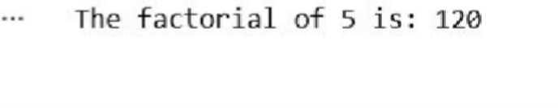

ASSIGNMENT-04

AIM :- Write a program to search for an item in a user – provided list and display the position if found, otherwise print “Item not Found.”

CODE :-

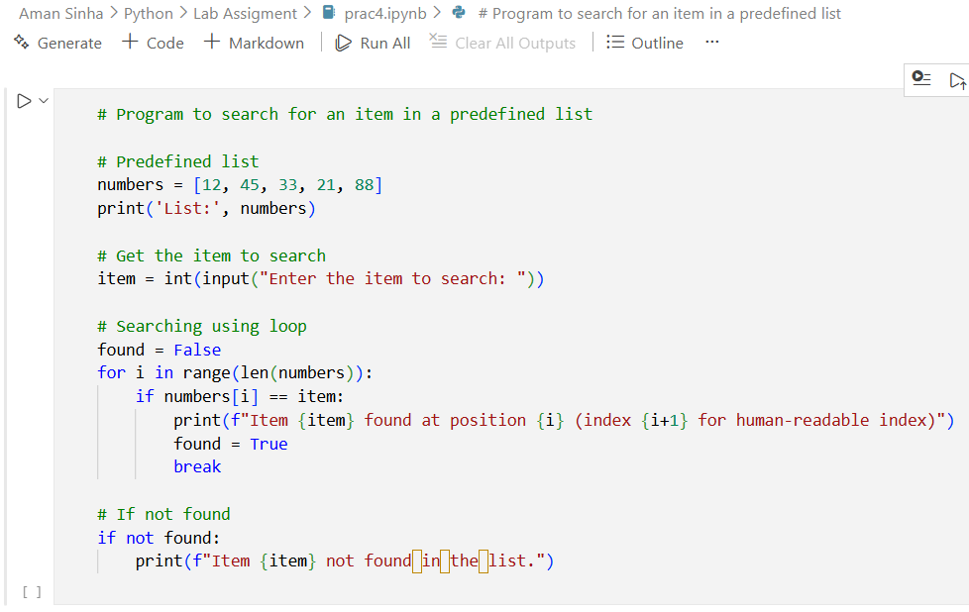

OUTPUT :-

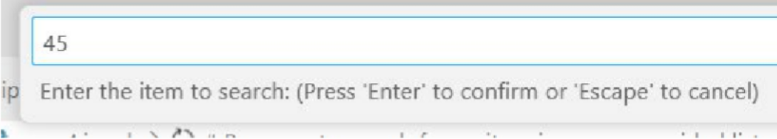

ASSIGNMENT-05

AIM :- Given a list of employee records as dictionaries , sort
them by salary and display the shorted list

CODE :-

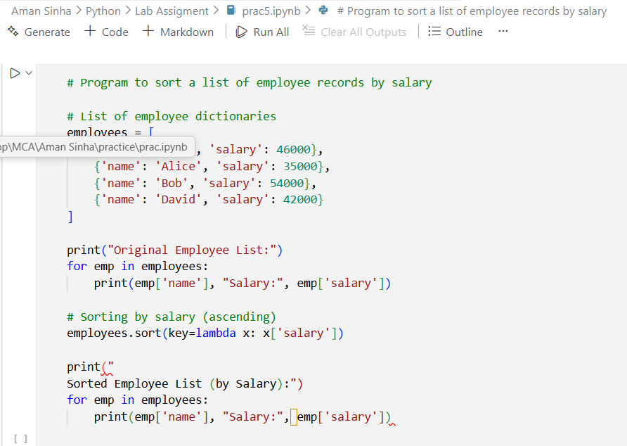

OUTPUT :-

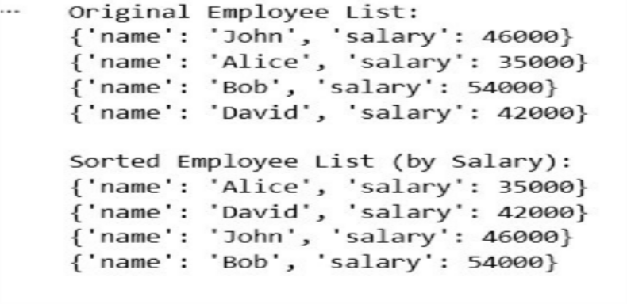

ASSIGNMENT-06

AIM :- Write a program that reads a text file and counts the number of lines, words, and characters.

CODE :-

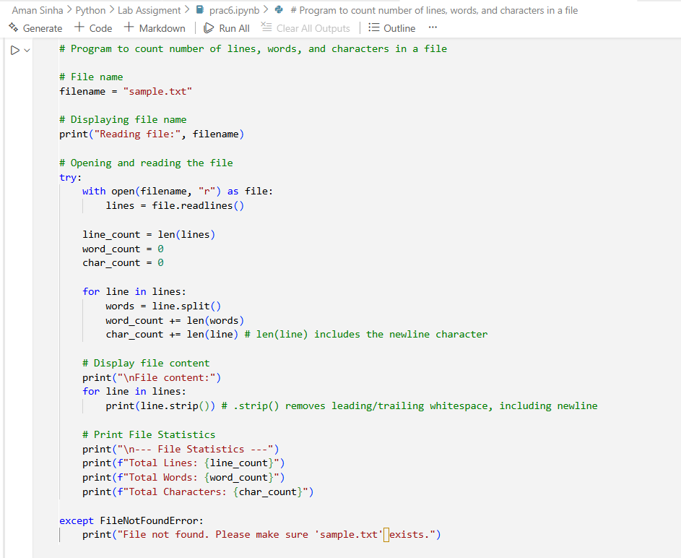

OUTPUT :-

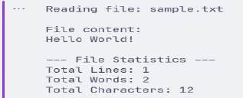

ASSIGNMENT-07

AIM :- Read a sentence and display how many times each word appears, ignoring case and punctuation.

CODE :-

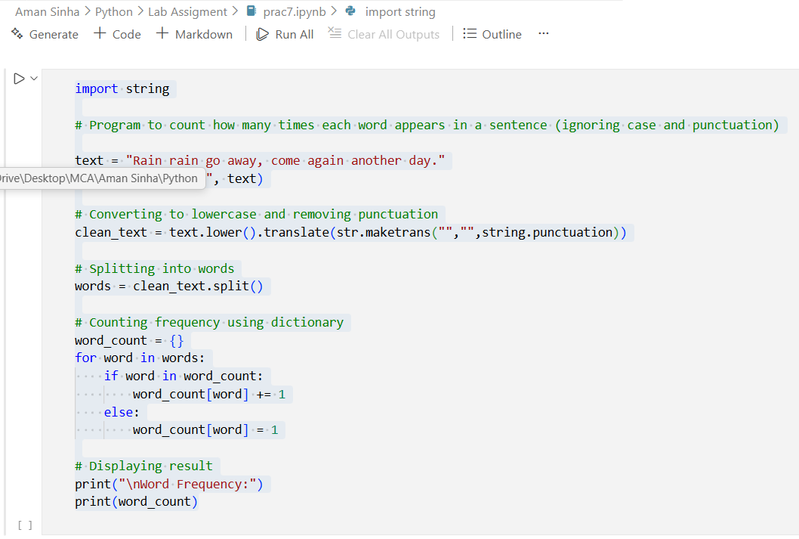

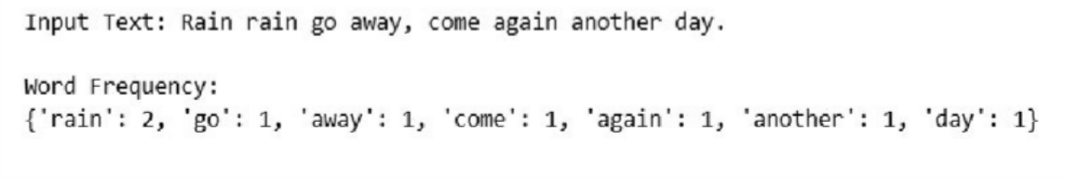
OUTPUT :-

ASSIGNMENT-08

AIM :- Write a program that lists all files in a directory a categorizes them by file extention.

CODE :-

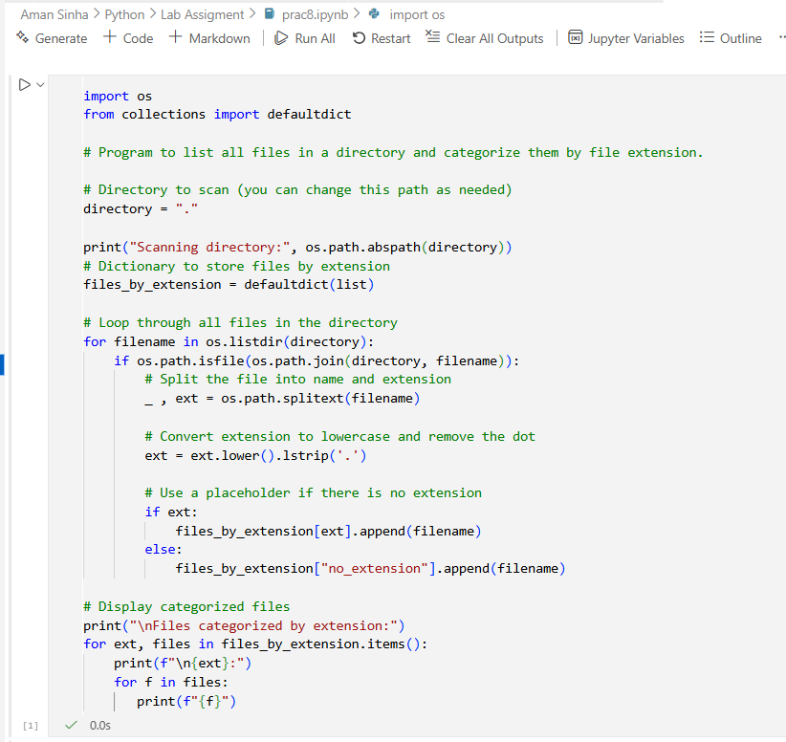

OUTPUT :-
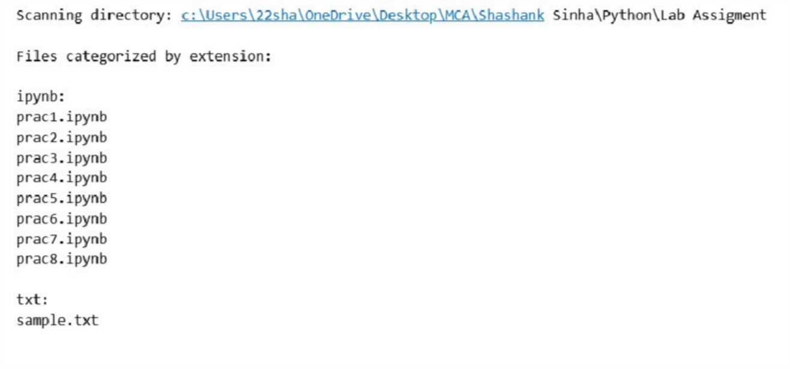

ASSIGNMENT-09

AIM :- Inside the circle.py module, create a class Circle that demonstrates by using a separate Point class (for center coordinates). Write the code for both classes.

CODE :-

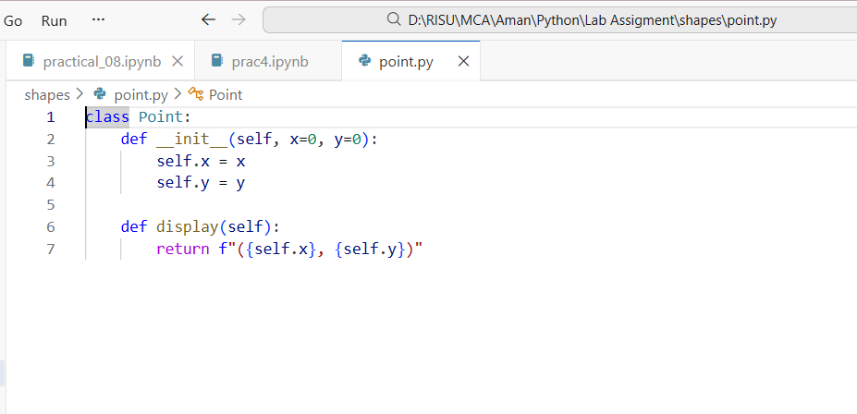

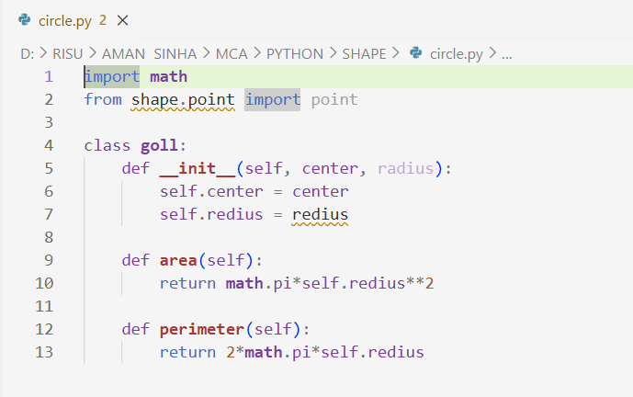
ASSIGNMENT-10

AIM :- Add an _init_.py file inside the shapes package that exposes only Circle and Rectangle using _all_. Write code to show how from shapes import * will work after this.

CODE :-

Module 1: __init__.py

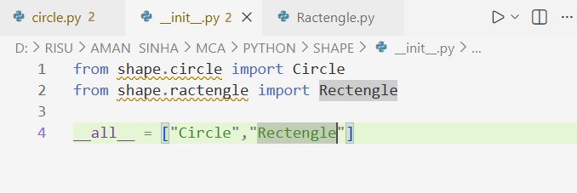

Module 2: Circle.py

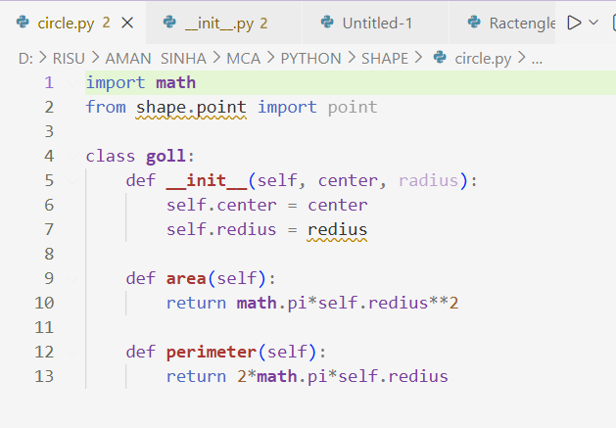
Module 3: Ractengle.py

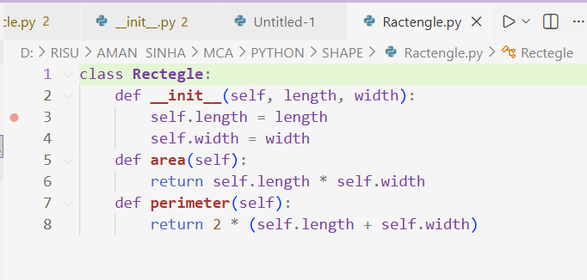

Module 4: Point.py

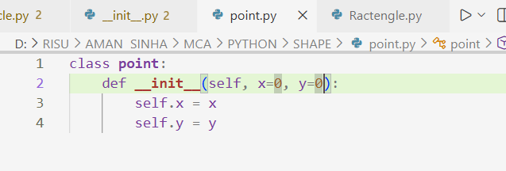

Directory Sample :-

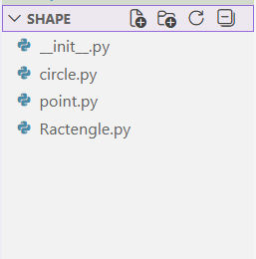

CODE :-

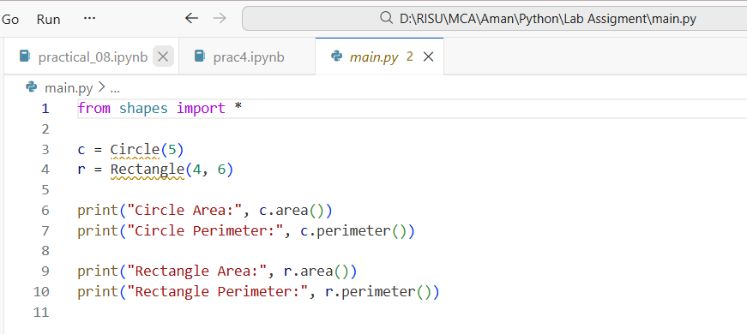

OUTPUT :-

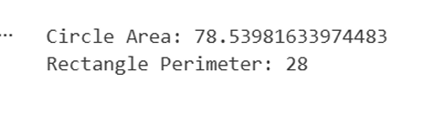
ASSIGNMENT-11

AIM :- Write a program in main.py to import the shapes package using both:

- Absolute imports
- Relative imports (inside package)

CODE :-

Module 1: point.py
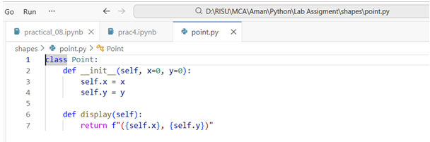

Module 2: circle.py

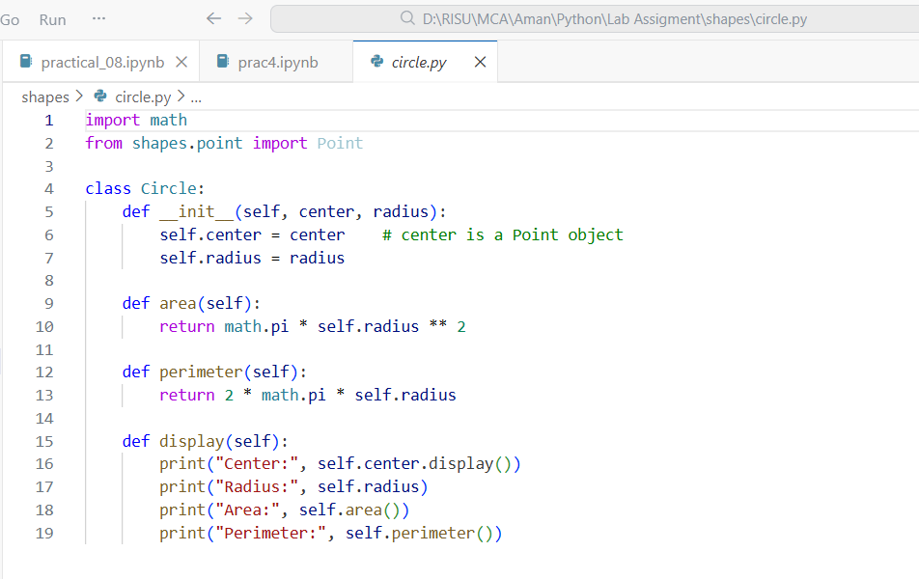

Module 3: Ractengle.py

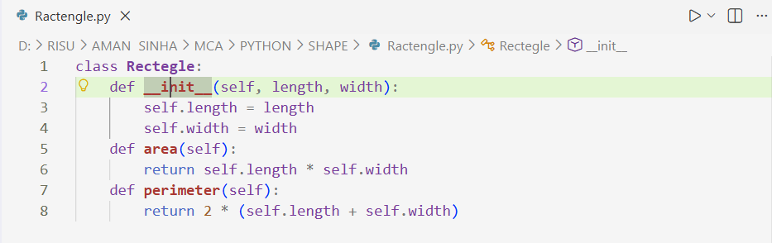

Module 4: Main.py

Directory Sample :
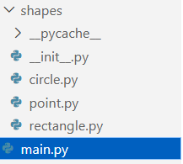

OUTPUT :-
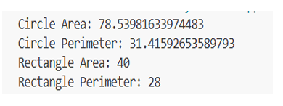
ASSIGNMENT-12

AIM :- Write a Python program that reads two numbers from the user and performs division. Use try-except to handle the following exceptions:

- ValueError (if the user enters non-numeric input)
- ZeroDvisionError (if the second number is zero)
- Display appropriate error messages.

CODE :-
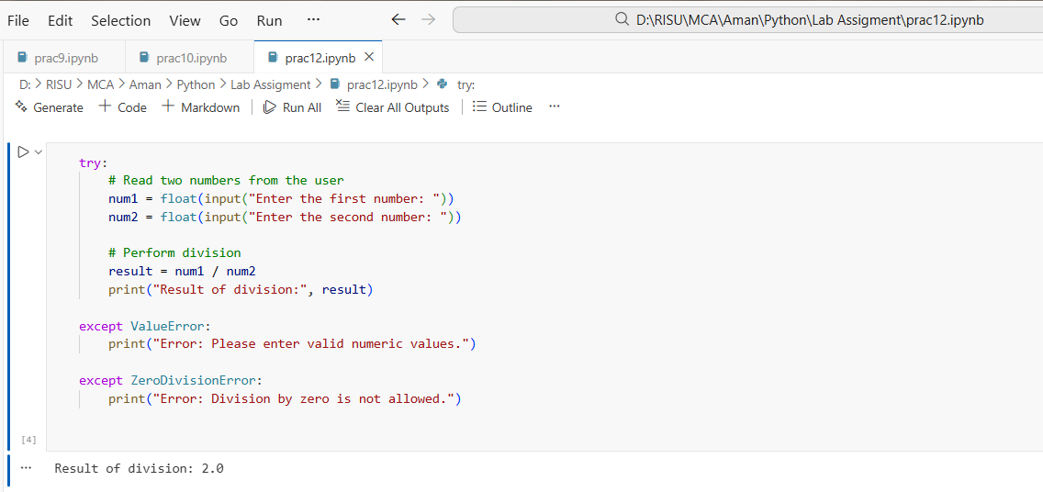

INPUT:-

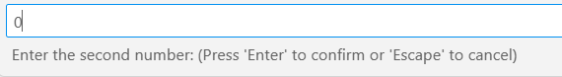

OUTPUT :-
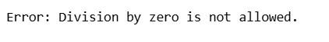

INPUT:-

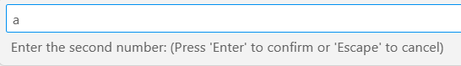

OUTPUT :-

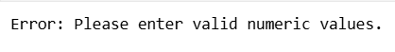
ASSIGNMENT-13

AIM :- Create a Python function read_file(filename) that opens and reads a text file. Use try-except-finally to handle:

- FileNotFoundError if the file does not exist
- PermissionError if the file cannot be opened

Finally FileNotFoundError block should print “File read attempt completed.”

CODE :-

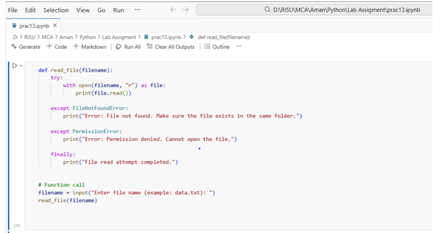

INPUT:-

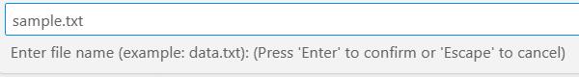

OUTPUT :-

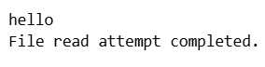

INPUT:-

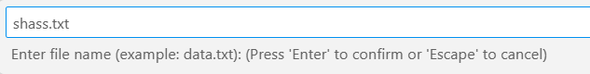

OUTPUT :-

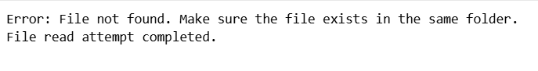
ASSIGNMENT-14
AIM :- Use California Housing datasets to build a Linear Regression model and print MAE and R² score.

CODE :-

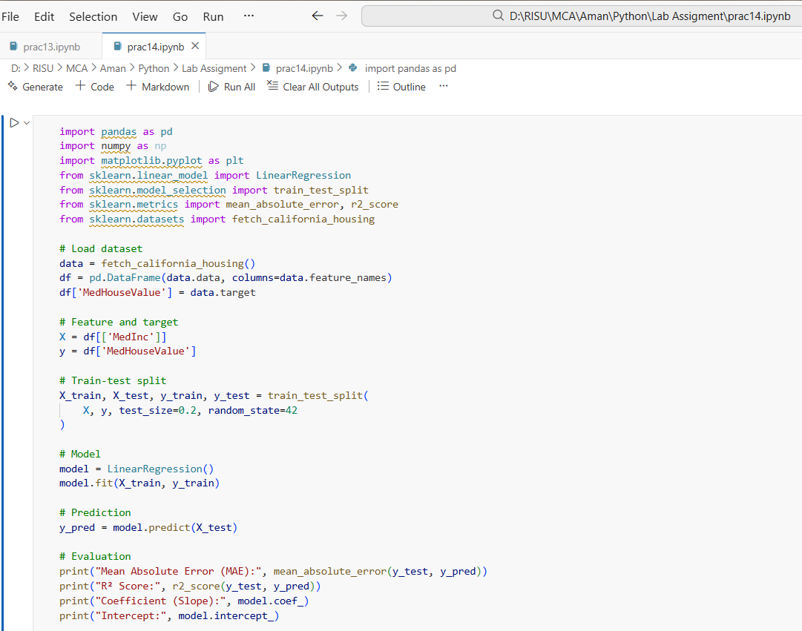
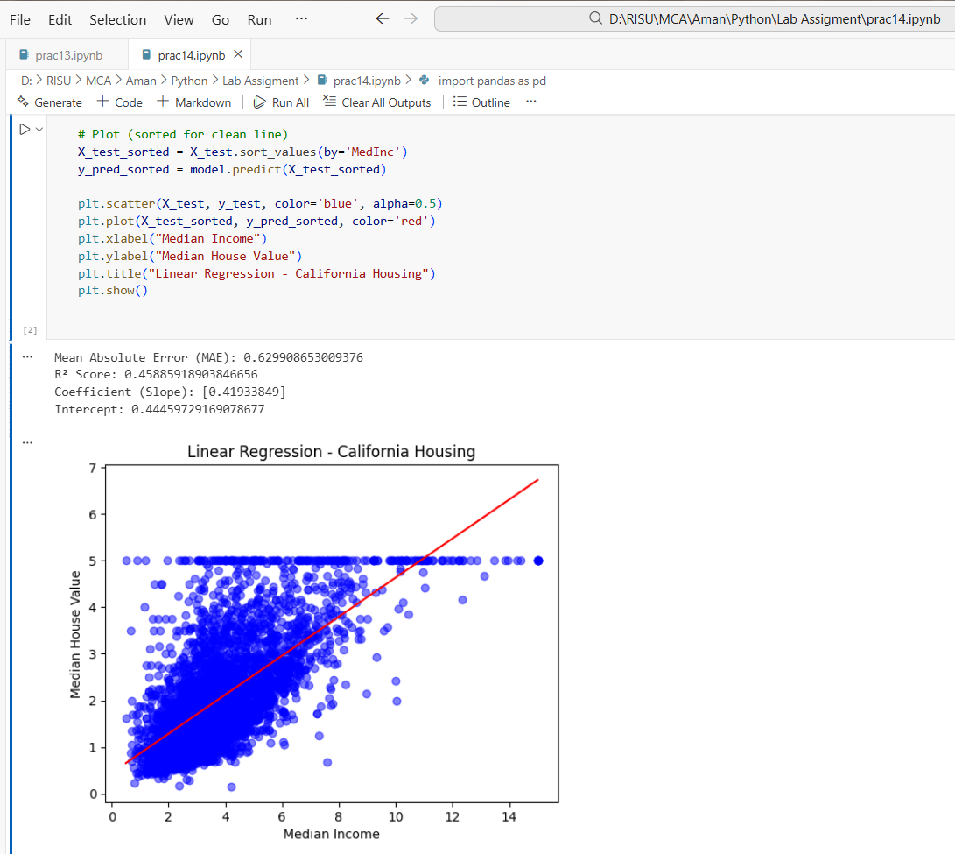

ASSIGNMENT-15

AIM :- Perform Agglomerative Hierarchical Clustering on the Iris dataset.

CODE :-

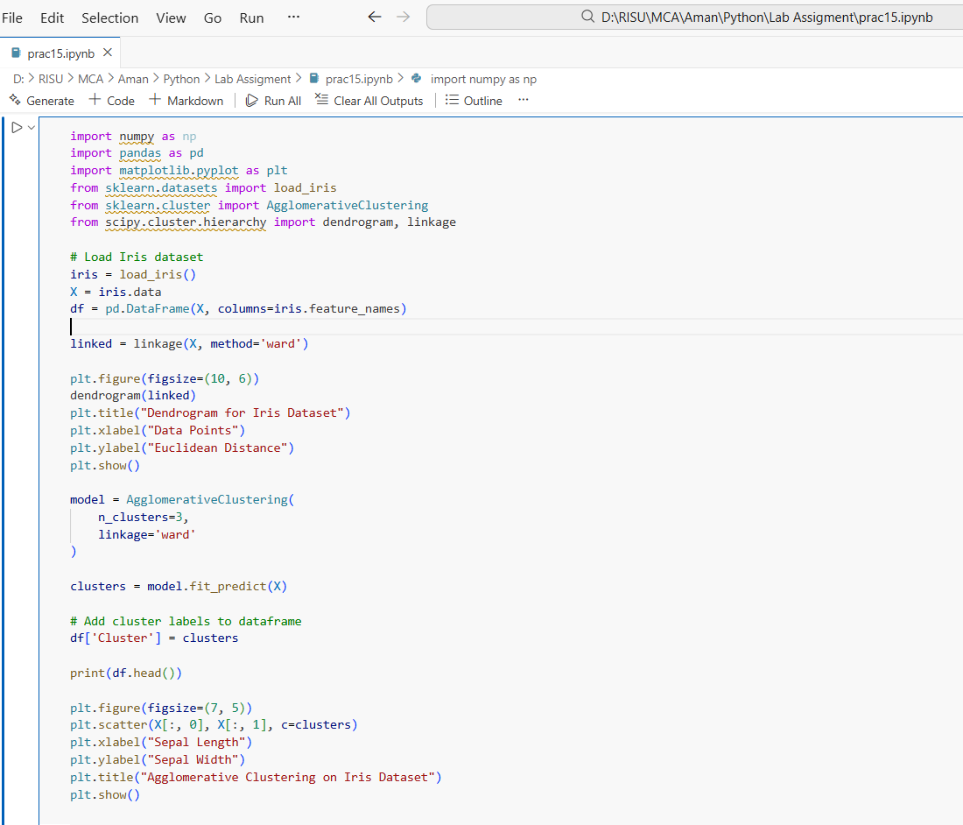

OUTPUT :-

